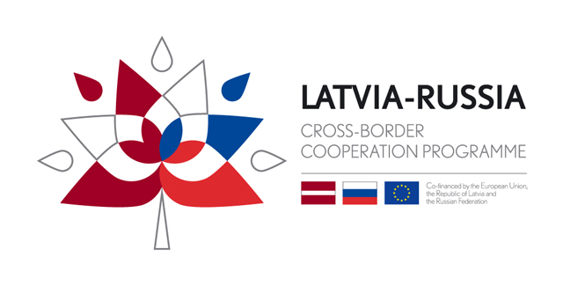
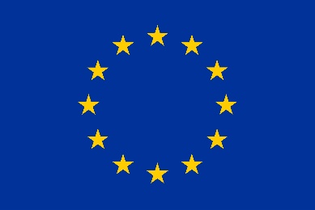
Co-funded by the European Union,
the Republic of Latvia and
the Russian Federation

AMATEUR VIDEO COMPETITION
WITHIN EUROPEAN COOPERATION DAY 2019

Aim and context of the amateur video competition

Latvia-Russia Cross-Border Cooperation Programme 2014-2020, in the framework of the EC DAY campaign 2019, organises an amateur video competition to raise citizens’ awareness about the benefits of being part of Europe and engage them in the values of cooperation. The aim is to capture the essence of a European spirit and feeling through a video that would ‘speak’ to both stakeholders and the general public.

Participants will have to make a very short video (maximum duration: 40 seconds) responding very briefly to the question: “Why EUROPE IS YOU?” (how Europe benefits you), which is the slogan of the EC DAY 2019 campaign.

The competition is open to every citizen of/resident in the cooperation area, as well as high school and university/college students.

In July, the jury will select the finalist videos. The final winner will be selected by the people attending the EC Day local event in September. The winning video will receive 2 smart watches and an official award (certificate) acknowledging this recognition.

The video competition will take place from 13 May to 30 June 2019. The awarding is scheduled during the week of 21 September 2019 or surrounding weeks (date tbc)

Technical specificities of the videos, eligibility and other requirements

- Any video must address the topic ‘EUROPE IS YOU’
- Each video should convey a clear message that clearly relates to the concept ‘EUROPE IS YOU’ as promoted by the EC DAY 2019 campaign.
- Therefore, each participant will have to explain why Europe is/benefits them. This can be said or it can be presented in an original way: drawing, writing, acting…
- Videos illustrating static events and meetings should be avoided, e.g. people sitting and listening to a speech/presentation.
- Videos can depict animated or/and real images.
- Aesthetic quality and creativity of the video must be assessed, too.
- All videos must be sent to latrus.ecday@gmail.com accompanied by a written form (SEE ANNEX 2) and a signed authorisation in case the participant is under 18 years old (SEE ANNEX 3)
- The videos must have good quality (at least 720p in order to be able to present the video on large screen)
- Maximum length of the video is 40 seconds; shorter videos will also be appreciated by the juries.
- The video can be recorded in English or in the local language. Each programme will have to submit to Interact the English translation of the text of the winner video. Interact will then include the English subtitles.
- All videos will be checked by programmes to make sure that they meet the competition rules before being assessed for the local competition.
- Videos that are offensive, defamatory or obscene, or that disclose unnecessary personal information or product advertisement will be rejected.
- Please, ensure that, apart from the copyrights, videos are in line with the new EU General Data Protection Regulation (GDPR). The programme will have the right to disseminate all submitted videos through their communication channels, social media and events, for strictly-related communication purposes.
- Also, in line with GDPR, participants under 18 years old must include an authorisation signed by their parents or legal tutors.
- To take part in the competition, videos must fulfil all of the above requirements.
Would you like to participate? Send an email to latrus.ecday@gmail.com with the following:
- Your video (if it’s too heavy they can use WeTransfer or make .zip files).
- The written application form
- Authorisation sheet (if you are under 18 years old)

Selection process

The best videos will be pre-selected by a jury set up by Latvia-Russia Cross-Border Cooperation Programme 2014-2020 programme.

The jury’s decision will be based on the following criteria:
- relevance to the competition aim
- aesthetic quality (including music, editing, effects)
- creativity (the idea, the topic, the originality, the story, if the video keeps the viewer’s attention till the last moment)

Rewards

Latvia-Russia Cross-Border Cooperation Programme 2014-2020 will award the winning project during the EC DAY local event with a specific prize (2 smart watches). All participants will be informed on the location, date and time of celebration by phone or email they indicate in the application form.

General terms and conditions

- The contest is open to citizens from and/or living in the cooperation areas of all 2014-2020 Interreg programmes (cross-border, transnational, Interregional), Interreg IPA-CBC and ENI-CBC programmes.
- The participants must be over the age of 18. If not, they will have to also send an authorisation signed by their parents or legal tutors.
- Programmes must submit only proposals where they are sure that all the videos have been verified and checked.
- All participants are responsible for any costs or expenses incurred as a result of participation in the contest.
- Participants and winners agree that they may be required to take part in publicity or other promotional activities without further consent or payment as later determined by Interact. Such publicity may include their names, videos, as well as any contributions in the online contest. The participant hereby grants the programme and the EU institutions the rights necessary for distribution and public display of any submitted text, image, or other intellectual property rights that may arise from participation in this contest, the prizes or related publicity, and hereby grants Interact and the EU institutions the perpetual right to exclusively, royalty-free and unlimited use, to edit, reproduce, distribute, translate, and publicly display or publish any such intellectual property, for whatever purpose, in any form or medium, either on this website or elsewhere, for promotional activities or events arranged by the programme or the EU institutions, whether locally or world-wide.
- Any personal information, including the participant’s name, age, address (including postcode) and e-mail address will be used solely in connection with this contest and will not be disclosed to any third party except for the purpose of this contest (including subsequent promotions as stated in these terms and conditions).
- By submitting your video, you confirm that EACH identifiable person who appears in your video has granted the rights to be recorded on video in image, likeness and sound of voice.
- The programme does not take any responsibility for late or lost entries.
- You must supply full details as required by this call and comply with all rules to be eligible for the contest and prize(s). No responsibility is accepted for ineligible applications.
- The videos should not contain any offensive or inappropriate language or content.
- The video entries must be submitted in the local language or in English.
- The prizes are as stated and are non-transferable and cannot be exchanged. No cash or credit alternatives will be offered. If, due to circumstances beyond Interact’s control, Interact is unable to provide the stated prize(s), Interact reserves the right to send as substitute a prize of equal or higher value.
- Music: please use royalty free music or original music that you have obtained the right for.
- Your participation in the contest, including being selected to present, in no manner constitutes an endorsement or support by the programme or the EU institutions of your views, aims, or of any products or services.
- By submitting one application, the participants accept the official rules of the contest.
- The organisers hold the right to reject any video that does not comply with the Terms of Reference, and that is not in accordance with the democratic values of the European Union.

