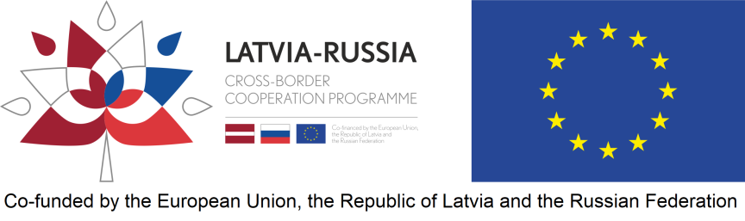

Project Lead Beneficiary Statement for Consolidated Project Report
Project number
Project title
Project acronym
Lead beneficiary
Reporting period number
Reporting period (dd/mm/yyyy - dd/mm/yyyy)
Programme co-financing reported

By signing this statement the lead beneficiary confirms that:
- the project neither in whole nor in part has or will receive any other additional EU, national or foreign financial instruments funding (except for the funding indicated in this project progress report) during the whole duration of the project;
- the lead beneficiary and all project beneficiaries have acted according to the provisions of the relevant national legislation and EU regulations, Financing agreement as well as the specific provisions of the Latvia - Russia Cross-border Programme 2014–2020;
- information and documentation in this project report and its attachments and if requested those that will be provided as additional clarifications are true and give a correct description of the implementation and the current status of the project.
Lead beneficiary organisation’s official title in English
Name and position of the authorised representative
Signature
Date of signature

Amount of Programme co-financing reported in EUR must match the amount indicated in consolidated report form worksheet “X Reported costs”.

